Climate change adaptation planning for local government


Contents
Developing an adaptation plan 3
Stock-take of existing adaptation activity 5
Adaptation Response Options 6
Prioritizing reponse options 12
Useful resources 13

Contact:
Rob Law, NAGA Project Manager
Email: rob@mefl.com.au
Last updated 3 June 2015

Developing an adaptation plan
There are many approaches to take when trying to start the adaptation planning cycle, and there are countless adaptation guides/manuals/toolkits that can make the process overwhelming. In an attempt to simplify the steps here are some thoughts to consider when developing a council adaptation plan. By no means is it the best approach, but it is an approach nonetheless, and at some point you need to lock in on an approach, or forever be lost in the labyrinth of adaptation frameworks and theory!
- What are your main goals for adaptation?
  - It is worthwhile in the outset to have an agreed long term vision for the plan, as well as some goals and adaptation principles. Example visions and principles can be found from other plans and are often similar to each other.
  - The goals however help to set the scope. Adaptation is big and complex, so it can help to identify a focus area for your plan. Is it to build organisational capacity? If so, then the process would need to engage staff widely and may seek to embed climate change risks across different service areas. It may also seek to ensure ownership of risks is adopted by each department, and integrated with service delivery plans.
  - Is it to identify specific adaptation actions?
  - Of course the plan may be both, and this is ideal, but it can help to make the two streams explicit; building adaptive capacity and delivering adaptation actions.
- Identify embedding approach and scope
  - Will you focus on select service areas, or whole of council approach?
  - Will it focus on council assets, operations and service delivery responsibilities, or look to engage community, industry and other stakeholders?
  - Garner executive support, depending on your council, good to focus on existing impacts and opportunities, and hedge in terms of legal liability and or costs of inaction
- Undertake stocktake of adaptation activity and governance capacity within your council
  - A good place to start is to do a scan of strategies and plans and capture what is already happening. See section 2 for stocktaking suggestions.
- Choose method
  - Will you need to undertake a risk assessment first, or is there enough information to begin adaptation planning? Risk assessments can be a good process for getting buy in from different parts of council, but have their pros and cons.
  - Do you wish to undertake an integrated vulnerability assessment? This requires more resources than a risk assessment, and if a NAGA council could use the existing data from the IRVA and infill where needed with more locally specific data.
  - How will you identify adaptation actions? Through workshops, staff interviews, literature? This is a good chance for further capacity building so should be used as an opportunity to make staff more aware of a) what they are currently doing and what others in the region are doing, and b) how climate change impacts their work area, and c) what they could be doing to reduce these impacts.

- Develop plan
  - From the data collected in workshops/surveys/interviews/lit review, prioritise actions using a prioritisation framework or some other method (see section 3 as an example).
  - Develop implementation schedule; set dates, responsibilities and costings for actions
  - Identify review date
- Develop a monitoring and evaluation framework
  - This ideally is developed at the beginning of the process, but the M&E framework should aim to track both capacity and actions over time. An M&E framework that may be of use is found at the EAGA website http://eaga.com.au/wp-content/uploads/MEFramework.pdf. An M&E framework could focus on the two streams of work; how well has climate change adaptation been mainstreamed
and embedded into council organisational processes, and how well has the plan been implemented and led to action and improved decision making. Measuring adaptation is complex, and a project is underway through the Western Alliance for Greenhouse Action to develop adaptation indicators.

Work to an adaptation planning framework. This is one of my favourites, coming from the ICLEI Canada work, which can be adapted to suit your needs:
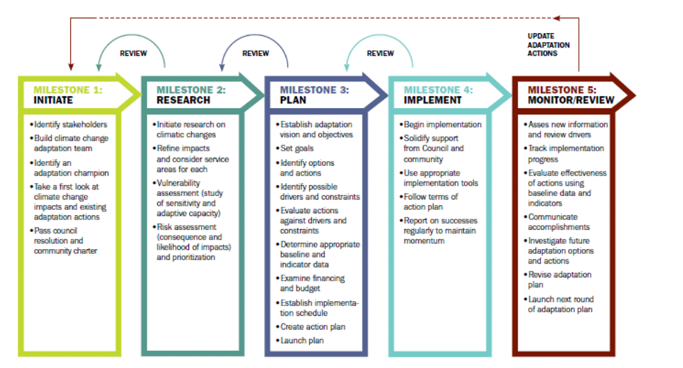

Stock-take of existing adaptation activity
It can be useful to look through each of the major plans for each service area of your council, including the corporate plan and assess whether it is likely to be exposed to climate change impacts or have any influence over climate change decision making.
The following questions could be considered by council staff when reviewing plans and strategies:
1. Does the plan or strategy need to consider climate change?
2. If so, does the plan or strategy already consider climate change in detail?
3. Has the plan considered adaptation response as well as mitigation?
4. Are there strong elements that would be considered adaptation but are not necessarily labelled as a climate change adaptation activity?
5. Are there specific actions beyond simply referring to the risks of climate change?
6. How well integrated throughout the different areas of council is climate change adaptation?
Whilst reviewing the plans/strategies it may be useful to rate according to the following scale or similar:
Rating description | Suggested action
Climate Change well referenced and integrated across multiple service objectives | Identify service areas where integration could be strengthened
Climate change mentioned but only as an environmental issue or mitigation issue | Seek to develop concept of climate change to adaptation in future updates/review and pursue integration across other areas
No reference to climate change, but includes what could be considered adaptation activities | Likely to need active awareness raising and capacity building across council, seek to engage with key staff in next review and potentially develop an issues brief for your Executive Management Team (EMT)
Poor consideration of climate change, where plan does not address key risks or areas of vulnerability in the face of climate change projections, and or is likely to exacerbate adverse consequences. | Needs immediate attention. Likely to need active awareness raising and capacity building across council, seek to engage with key staff in next review and develop an issues brief for EMT

Adaptation Response Options

The following is a synthesized collection of adaptation actions/measures for common adaptation objectives. This was compiled from reviewing local government adaptation plans across the country and overseas. This can be useful to gain an understanding of what existing adaptation options are out there when designing your own plan, but also to communicate to different service areas of council.
Adaptation objective | Adaptation measure/action
Improving the resilience of built infrastructure | Conduct a regional council building vulnerability assessment and seek funding for targeted upgrades
Improving the resilience of built infrastructure | Undertake buildings resilience upgrade in combination with energy efficiency upgrades to leverage financing mechanisms (eg EPCs)
Improving the resilience of built infrastructure | Research life cycle costs and payback periods of different ESD standards for council buildings
Improving the resilience of built infrastructure | Continue to advocate through MAV and CASBE for a statewide ESD Policy in the Victorian Planning Provisions
Improving the resilience of built infrastructure | Identify network of critical council facilities for potential off-grid renewable energy backup supply during heatwaves and other extreme weather events
Improving the resilience of built infrastructure | Conduct training for staff to increase awareness of energy and water use behaviours in identified council buildings
Improving the resilience of built infrastructure | Develop a coordinated and consistent ESD policy and guidelines throughout the region for council buildings
Improving the resilience of built infrastructure | Advocate for council buildings to showcase best practice sustainable design
Improving the resilience of built infrastructure | Develop asset monitoring framework to enable collection of data to establish trends in degradation of assets as a result of climate change
Improving the resilience of built infrastructure | Review current council asset management plans, maintenance programs and asset registers to ensure they support robust and effective long term adaptation to climate change
Improving the resilience of built infrastructure | Develop a regional asset managers and engineering adaptation to share best practice case studies, excursions and regional forums
Improving the resilience of built infrastructure | Develop infrastructure and climate change adaptation guidelines for developers, planners, decision makers (ref: City of Greater Geelong)
Improving the resilience of built infrastructure | Work with state government to develop guidelines for standard procedures for asset condition assessment
Improving the resilience of built infrastructure | Develop procurement guidelines to encourage suppliers to consider and tender against climate adaptation objectives (ref UKCIP)
Improving the resilience of built infrastructure | Develop cool roof research project looking at large roof to volume ratios and that could be painted with reflective white paints
Improving the resilience of built infrastructure | Work with Distribution Network Service Providers to identify regional energy initiatives for improving energy resilience and alleviating energy poverty for vulnerable people
Improving the resilience of built infrastructure | Develop a regional eastern urban forest/green infrastructure strategy, identifying thermal hotspots, common standards, shared learnings and solutions etc. (ref: Greening the West, City of Melbourne urban forest strategy)
Reduce regional urban heat island effect | Work with regional stakeholders to pilot more heat tolerant, permeable and reflective bitumen/pavement materials
Reduce regional urban heat island effect | Conduct regional shade audit for targeted green infrastructure and shading initiatives
Reduce regional urban heat island effect | Review existing development controls for heat island effect, seeking to ensure new developments do not exacerbate heatwaves
Reduce regional urban heat island effect | Review/prepare design guidelines for street furniture, shelters and awnings
Reduce regional urban heat island effect | Promote green infrastructure and shade structures in new council recreational facilities
Reduce regional urban heat island effect | Community education campaign on broad values of street trees
Reduce regional urban heat island effect | Amend existing council procurement requirements to reflect urban design principles that consider extended heatwaves
Reduce regional urban heat island effect | Work with research institutions (eg.Monash/Swinburne Universities) to map thermal hotspots and social vulnerability
Reduce regional urban heat island effect | Conduct regional economic analysis of heatwave impacts in Melbourne’s east, focussing on strip shopping precincts
Reduce regional urban heat island effect | Work with strip shopping businesses to create a business ESD scheme/revolving energy fund for increasing resilience of strip shopping to extreme weather events and heatwaves
Improving the adaptive capacity of the local economy | Develop an adaptation network with government agencies, businesses and other stakeholders (ref. Inner Melbourne Network)
Improving the adaptive capacity of the local economy | Develop a business climate toolkit and self assessment checklist for engaging SMEs in the region to build understanding of adaptation (ref: Sefton Council, UK)
Improving the adaptive capacity of the local economy | Design criteria for new transport infrastructure to consider projected climate impacts and guidance for asset managers to incorporate when installing new road or bridge infrastructure
Improving the resilience of transport infrastructure | Undertake a cost benefit analysis of new road building technology and additives, taking into consideration changes to the asset life of roads.
Improving the resilience of transport infrastructure | Work with community to develop community flood response plans
Improving the resilience of transport infrastructure | Work with regional bodies such as SES and other councils to develop maps which identify roads susceptible to flooding, the location of vulnerable populations and alternative routes to reach these vulnerable populations and other key areas in the case of road closure.
Improving the resilience of transport infrastructure | Regional downscaled modelling of climate change and associated hydrological projections
Improved regional water management | Identify regional opportunities for expansion of stormwater harvesting and reuse
Improved regional water management | Collaborate between councils to identify regional water harvesting/grey water projects
Improved regional water management | Develop standard guidelines for irrigation management and water availability strategies
Improved regional water management | Promote warm season and drought tolerant grass species in sporting grounds and reserves
Improved regional water management | Promote household water energy efficiency and demand management in conjunction with water retailers
Improved regional water management | Work with water bodies to integrate climate change risk responses into regional floodplain management strategy
Improved regional water management | Model using remote sensing pervious and impervious surfaces across the region, and develop strategy for improving the ratio through WSUD
Improved regional water management | Develop standardised reporting system for blocked drains
Improved regional water management | Upgrade sports facilities with more water efficient surfaces and share learnings
Improved regional water management | Promote WSUD at plan making and development assessment stages and minimise hard surfaces such as pavements
Improved regional water management | Undertake an assessment of alternative water quality techniques that can be installed in council owned water catchments to increase turbidity and limit algae growth (eg. Solar powered bee or SunMixeri3)
Improved regional water management | Engage with water quality consultants to adapt monitoring systems for increased extreme heat
Improved regional water management | Consider provisions for movement of biodiversity within a regional urban forest strategy
Improved environmental management & biodiversity conservation | Develop a procurement project for regional sharing arrangements of arborists after major storm events
 | Promotion of increased mowing heights and mulching during periods of low water availability
 | Provisions for increased regular maintenance of parks and reserves within council budgets and management plans
 | Adopt a biodiversity monitoring framework to understand the impacts of climate change and develop appropriate responses (ref EAGA Monitoring Biodiversity Monitoring Framework)
 | Develop a community support strategy for biodiversity in extreme weather events such as fire and heatwaves
 | Work together particularly along waterways to manage the increase in weeds as a result of climate change
 | Assist species relocation and/or regeneration
 | Protect migration corridors (e.g. coordinate with other levels of government and private landowners to ensure high connectivity)
 | Develop and invest in seed/gene banks for region
 | Development of state wide material and education for CALD groups around energy efficiency, heatwave preparedness and sustainability. Collating information from all councils to develop clear messages and save resources.
Build community adaptive capacity and protecting the vulnerable | Statewide capacity building program for HACC Staff to engage with vulnerable communities on energy efficiency and heatwave preparedness
 | A common strategy approach to deliver meals on wheels during red code days (eg. Councils sharing resources to hire services for delivery of meals on wheels, service trucks etc.
 | Regional solar rates project for facilitating renewable energy uptake on low income households
 | Development of a regional heatwave response action plan
 | Development of a regional heatwave alert system (ref: City of Melb)
 | Review OH&S policies to develop contingencies for accessing vulnerable people in extreme weather and extreme heat days
 | Community education package on storm preparation (eg. clearing gutters and drains)
 | Encourage scheduling of council events to avoid hottest part of day
 | Identify and develop register of vulnerable households to heatwave and storm events
 | Waive/reduce user fees for swimming pools and increase opening hours of council facilities in extreme heat days
 | Engage with primary care providers to ensure climate change is considered in the service delivery planning
 | Development of regional heatwave refuges identifying designated council cooling facilities
 | Improved standardised emergency communications to CALD community and extreme weather (including fire) education programs
Improving emergency preparedness and response | Conduct regional emergency preparation exercises consider multiple widespread events
Improving emergency preparedness and response | Advocate for more funding to emergency service agencies in line with increasing extreme events as a result of climate change
Improving emergency preparedness and response | Resource (personnel, plant) and information sharing
Improving emergency preparedness and response | Build a training program for CEOs to build capacity and champion adaptation through collaboration (eg. establish MoU)
Building organisational adaptive capacity | Develop adaptation resources/tools and regional events for sharing of knowledge, consolidating best practice case studies
Building organisational adaptive capacity | Investigate potential liability and insurance issues in relation to climate change and council decision making (particularly land use planning)
Building organisational adaptive capacity | Continue to review key council policies and plans to consider climate change projections
Building organisational adaptive capacity | Build staff capacity across council through service area based workshops and online resources
Building organisational adaptive capacity | Review departmental budgets in light of climate change, and monitor impacts of extreme weather events on service delivery and financial sustainability
Building organisational adaptive capacity | Consider contingency funding to extend to adaptation activities in annual budgeting processes
Building organisational adaptive capacity | Review business continuity plans for climate change projections
Building organisational adaptive capacity | Review financial planning procedures to include monitoring of increased costs as a result of climate change
Building organisational adaptive capacity | Review of insurance options for better management of assets from natural disasters (ref: ALGA and ICA review)
Building organisational adaptive capacity | Develop a climate change adaptation staff communications and training program
Building organisational adaptive capacity | Consider investment opportunities and payback periods when considering long term climate change actions
Building organisational adaptive capacity | Research on the potential financial impacts of climate change on existing land use planning and estimate costs of inaction versus costs of adaptation
Building organisational adaptive capacity | Review and update planning policies to incorporate best available climate projections
Building organisational adaptive capacity | Continue to work with MAV to seek further clarification around roles and responsibilities for local government and state government around adaptation and legal liability issues
Building organisational adaptive capacity | Work with regional health providers to develop public health education and heatwaves (safer food production and storage etc.)
Enhancing regional health and safety | Develop a regional extreme weather event guideline relevant to food safety
Enhancing regional health and safety | Develop with other authorities a regional environmental health strategy for long term management of vector and water borne diseases as a result of climate change
Enhancing regional health and safety | Review climate risk assessment and update health and wellbeing plans
Enhancing regional health and safety | Promote linkages between aged friendly cities and climate change adaptation objectives
Enhancing regional health and safety | Regional waste to food project involving redirecting organic waste to be used as compost for local food systems
Planning for food security in a hotter drier region | Assessment of regional waste streams and waste to energy feasibility study
Planning for food security in a hotter drier region | Identify land holdings for redirected use to local agriculture and community food such as YVW and MW
Planning for food security in a hotter drier region | Develop a planning tool with specific checklists and guidelines to help land use planners make better decisions around climate impacts
Improving planning decision making | Councils to adopt BESS as a planning tool to help think of adaptation in planning decisions
Improving planning decision making | Provide training for planners to understand latest climate change projections as it relates to land use planning

Prioritizing reponse options
Numerous prioritisation frameworks are available for determining adaptation responses. One framework which I found particularly useful is the following evaluation criteria from the Canadian Communities Guidebook for Adaptation to Climate Change. Other local governments are working on different prioritization tools, such as the City of Melbourne.
Table 1: Evaluation criteria for filtering and prioritising adaptation options
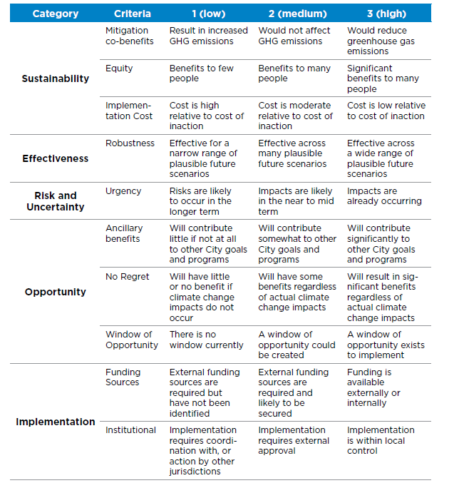

Useful resources

Guidance
A collection of adaptation guides and toolkits can be found here:
https://app.box.com/files/0/f/3229017834/Adaptation_guides_and_toolkits
Some of the more useful guides are:
For a good overview of different approaches to adaptation planning:
- MAV stocktake of current Victorian government local adaptation planning
- Adapting to climate change: A Queensland government guide (I have found this most useful)
- ACELG Climate change adaptation manual (also very useful for embedding ideas)
If pursuing the risk assessment approaches:
- Guide to climate change risk assessment for NSW Local Government
- AGO Climate Change Impacts and Risk Management
If pursuing an integrated regional vulnerability assessment:
- NSW Guide to Integrated Regional Vulnerability Assessment (IRVA) for Climate Change
- LGASA Guidelines for developing a climate change adaptation plan
For decision making guidance:
- RMIT/Net balance adaptation toolkit
Examples
Some good examples of local government adaptation plans:
https://app.box.com/files/0/f/3242004508/Other_Adaptation_Plans
There are many out there, and good to compare and contrast for what works for your council, but here are a few that I think are quite good and well put together, though it is quite subjective:
- City of Vancouver Adaptation Strategy
- Eyre Peninsula Adaptation Pathways regional plan
- City of Greater Geelong

